Project Design Phase
Solution Architecture
Date | 03 October 2026
Team ID | SWTID-2026-2230
Project Name | Streamlining IT Procurement: Automating  Standard Laptop Orders with Flow Designer
Maximum Marks | 4 Marks

Solution Architecture
The solution architecture describes how ServiceNow components work together to automate the standard laptop procurement process. The architecture connects the employee request, validation, manager approval, procurement task, notifications, and order tracking into one automated workflow.

Figure 1: Solution Architecture and Data Flow
┌───────────────────────┐
│ EMPLOYEE │
│ Submit Laptop Request│
└───────────┬───────────┘
│
▼
┌─────────────────────────────┐
│ SERVICENOW UI │
│ Laptop Request Form │
│ Request Status │
└─────────────┬───────────────┘
│
▼
┌─────────────────────────────┐
│ REQUEST MANAGEMENT │
│ • Validate Details │
│ • Check Laptop Availability │
└─────────────┬───────────────┘
│ Valid Request
▼
┌─────────────────────────────┐
│ FLOW DESIGNER │
│ Automated Workflow │
└─────────────┬───────────────┘
│
┌──────┴───────┐
▼ ▼
┌──────────────┐ ┌────────────────┐
│ MANAGER │ │ NOTIFICATION │
│ APPROVAL │ │ SYSTEM │
│ Approve/Reject│ │ Email / Status │
└──────┬───────┘ └────────────────┘
│ Approved
▼
┌─────────────────────────────┐
│ PROCUREMENT TASK │
│ Automatically Created │
│ Assigned to Procurement │
└─────────────┬───────────────┘
│
▼
┌─────────────────────────────┐
│ PROCUREMENT TEAM │
│ Process Laptop Order │
│ Update Order Status │
└─────────────┬───────────────┘
│
▼
┌─────────────────────────────┐
│ ORDER TRACKING │
│ Ordered → Shipped → │
│ Delivered → Completed │
└─────────────┬───────────────┘
│
▼ ┌───────────────────────┐
│ EMPLOYEE │
│ Status & Completion │
│ Notification │
└───────────────────────┘

┌────────────────────────────────────────┐
│ SERVICENOW DATA STORAGE │
│ Employee | Request | Approval │
│ Procurement Task | Order | Status │
└────────────────────────────────────────┘
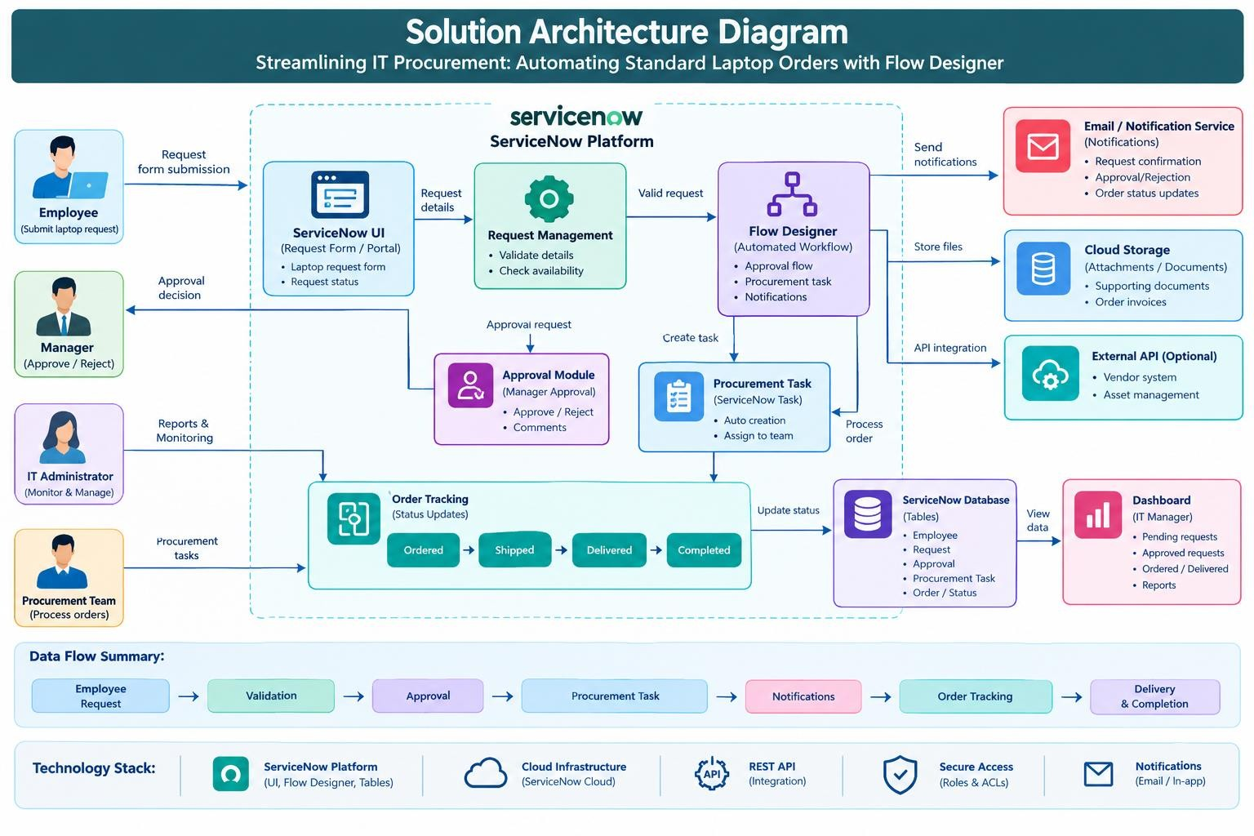

Architecture Components
Component Purpose
Employee Interface Allows employees to submit and track laptop requests.
Request Collects request information and validates mandatory Management details.
Flow Designer | Automates the complete procurement workflow.
Approval Module | Allows managers to approve or reject requests.
Procurement Task | Automatically creates and assigns procurement work.
Notification System | Sends request, approval and order-status notifications.
Order Tracking | Tracks the laptop from order placement to delivery.
ServiceNow Tables | Store employee, request, approval, task and order information.
Dashboard | Allows IT managers to monitor procurement progress.

Data Flow
Employee Request → Validation → Flow Designer → Manager Approval → Procurement
Task → Order Processing → Status Updates → Delivery → Completion

Key Benefits of the Architecture
- Reduces manual procurement activities.
- Automates approval and task creation.
- Provides clear request and order tracking.
- Improves communication through automatic notifications.
- Provides role-based access for employees, managers, IT administrators and procurement teams.
- Creates a centralized procurement workflow on ServiceNow.

